AI Prompt
I used this prompt and then asked AI to generate student learning outcomes for each chapter. Additional elements can be added.
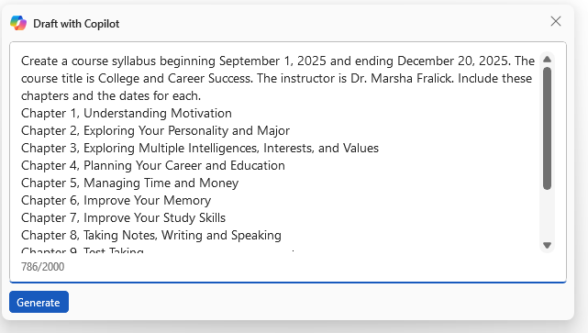

College and Career Success
  - Course Syllabus
Instructor: Dr. Marsha Fralick
Course Duration: September 1, 2025 - December 20, 2025

Week 1: Orientation
Dates: September 1 - September 7, 2025
Learning Objectives:
- Understand the course structure and expectations
- Get acquainted with classmates and instructor
- Learn about the importance of college and career success

Week 2: Chapter 1, Understanding Motivation
Dates: September 8 - September 14, 2025
Learning Objectives:
- Identify personal motivations for attending college
- Explore various motivational theories
- Develop strategies to enhance personal motivation

Week 3: Chapter 2, Exploring Your Personality and Major
Dates: September 15 - September 21, 2025
Learning Objectives:
- Understand different personality types
- Assess personal strengths and weaknesses
- Match personality traits with suitable majors and careers

Week 4: Chapter 3, Exploring Multiple Intelligences, Interests, and Values
Dates: September 22 - September 28, 2025
Learning Objectives:
- Learn about the theory of multiple intelligences
- Identify personal interests and values
- Connect interests and values to career choices

Week 5: Chapter 4, Planning Your Career and Education
Dates: September 29 - October 5, 2025
Learning Objectives:
- Create a detailed career plan
- Outline educational pathways to achieve career goals
- Understand the importance of lifelong learning

Week 6: Chapter 5, Managing Time and Money
Dates: October 6 - October 12, 2025
Learning Objectives:
- Develop effective time management skills
- Learn budgeting and financial management techniques
- Set financial goals for short-term and long-term success

Week 7: Chapter 6, Improve Your Memory
Dates: October 13 - October 19, 2025
Learning Objectives:
- Understand how memory works
- Explore methods to improve memory retention
- Apply techniques to enhance study practices

Week 8: Chapter 7, Improve Your Study Skills
Dates: October 20 - October 26, 2025
Learning Objectives:
- Identify effective study habits and environments
- Learn different study techniques
- Develop a personal study plan

Week 9: Chapter 8, Taking Notes, Writing and Speaking
Dates: October 27 - November 2, 2025
Learning Objectives:
- Master different note-taking methods
- Enhance writing skills for academic success
- Improve public speaking and presentation skills

Week 10: Chapter 9, Test Taking
Dates: November 3 - November 9, 2025
Learning Objectives:
- Learn effective test preparation strategies
- Understand different types of test questions
- Develop techniques to reduce test anxiety

Week 11: Chapter 10, Communication and Relationships
Dates: November 10 - November 16, 2025
Learning Objectives:
- Improve interpersonal communication skills
- Learn to build and maintain healthy relationships
- Understand the role of communication in professional settings

Week 12: Chapter 11, Thinking Critically and Creatively
Dates: November 17 - November 23, 2025
Learning Objectives:
- Develop critical thinking skills
- Explore creative problem-solving techniques
- Apply critical and creative thinking in academic and career contexts

Week 13: Chapter 12, Empower Yourself: Mental and Physical Wellbeing
Dates: November 24 - November 30, 2025
Learning Objectives:
- Understand the importance of mental health
- Learn techniques for physical wellbeing
- Develop strategies for maintaining overall wellness

Week 14: Chapter 13, Thinking Positively about the Future
Dates: December 1 - December 7, 2025
Learning Objectives:
- Adopt a positive mindset for future success
- Set long-term goals and aspirations
- Develop a plan for achieving future objectives

Week 15: Assessment
Dates: December 8 - December 14, 2025
Learning Objectives:
- Evaluate personal progress and achievements
- Reflect on learning experiences throughout the course
- Identify areas for future improvement and development

